REPORT

THIS IS A WEBSITE WHICH IS CREATED BY

* **AKSHIT RAWAT (11908341)**
* **PRATEEK NANDA (11908352)**
* **SAHIL (11908312)**

OF SECTION-: K19GE.

INTRODUCTION:-

THIS IS A WEBSITE WHICH SHOWS THE ACTUAL WORKING OF AN E-COMMERCE/SHOPPING WEBSITE. THE NAME OF THE WEBSITE IS **BLUE LAGOON SHOPING**. THE WEBSITE CONTAINS:

* LOGIN PAGE
* CUSTOMER SERVICE PAGE
* CART PAGE
* ACCOUNT MANAGEMENT PAGE
* CATEGORY BAR (including ELECTRONICS, GROCERIES, FASHION, KITCHEN AND ACCESSORIES as options)
* OFFERS BAR (Including DISCOUNT, CASHBACK, PRIME OFFER, as options).

THIS WEBSITE LETS A PERSON/CUSTOMER BUY GOODS OF THEIR INTEREST LIKE **CLOTHING, GROCERIES, ACCESSORIES ETC** & ADD THE PRODUCT OF CHOICE IN CART, SO THAT THEY CAN BUY THE PRODUCT(s) IN THE FUTURE. IT CONTAIN TOTAL 12 PAGES. EACH PAGE HAS BEEN CREATED WITH THE USE OF **HTML, CSS, AND JAVASCRIPT**. THIS IS A CUSTOMER FRIENDELY WEBSITE.

FLOWCHART

WEBSITE

LOGIN PAGE

HOME PAGE

HOME **(CUSTOMER** (LOGIN/ **CART** (YOUR **CATEGORY**  OFFERS

**SERVICES)** SIGNUP) ACCOUNT)

> ELECTRONICS > DISCOUNT

> GROCERIES >CASHBACK

> FASHION > PRIME OFFER

> KITCHEN

> ACCESSORIES

DESCRIPTION OF THE PROJECT

THIS IS A SHOPPING WEBSITE NAMED **BLUE LAGOON SHOPPING**.THE WEBSITE STARTS WITH A *LOGIN PAGE* WHERE A PERSON HAS TO ENTER HIS\HER *USERNAME* & *PASSWORD* TO LOGIN. AFTER LOGIN THE *HOMEPAGE* IS DISPLAYED. THE HOMEPAGE CONTAINS OPTIONS LIKE

* **‘HOME’** *WHICH GIVES THE BRIEF DESCRIPTION ABOUT BLUE LAGOON SHOPPING.*
* **‘CUSTOMER SERVICES’** *WHICH MAKES THE CUSTOMER AWARE ABOUT THEIR SERVICES PROVIDED BY BLUE LAGOON SHOPING.*
* **‘LOGIN/SIGNUP’** *WHICH LETS THE USER LOGIN INTO THEIR ACCOUNTS.*
* **’CART’** *WHICH CONTAINS THE ITEMS ADDED TO THEM.*
* **’YOUR ACCOUNT**’ *WHICH CONTAINS DETAILS OF MODE OF PAYMENT, ‘CATEGORY’ WHICH ALLOW THE CUSTOMER TO* BUY GOODS OF THEIR INTEREST.
* **‘OFFER’** *WHICH PROVIDES THE INFORMATION TO THE CUSTOMER ABOUT THE OFFERS PROVIDED BY BLUE LAGOON SHOPING LIKE DISCOUNT, CASHBACK, PRIME OFFER.*

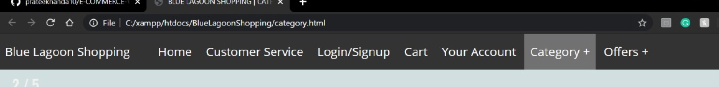**MODULES**

**WEB PAGES OF WEBSITE**

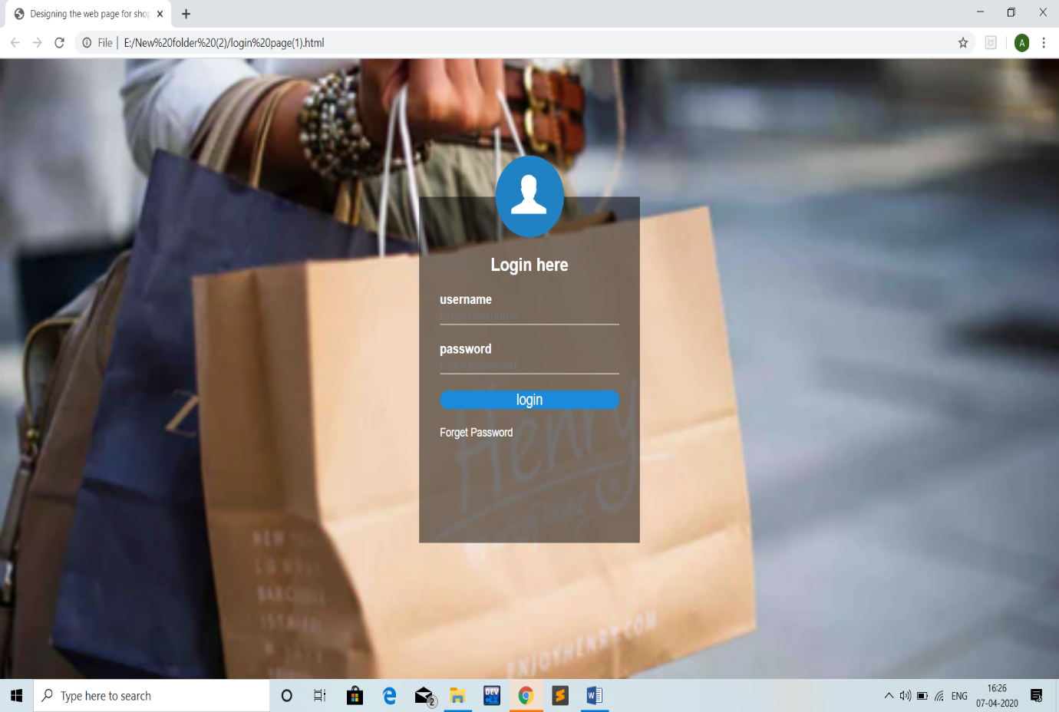1.**LOGIN PAGE**

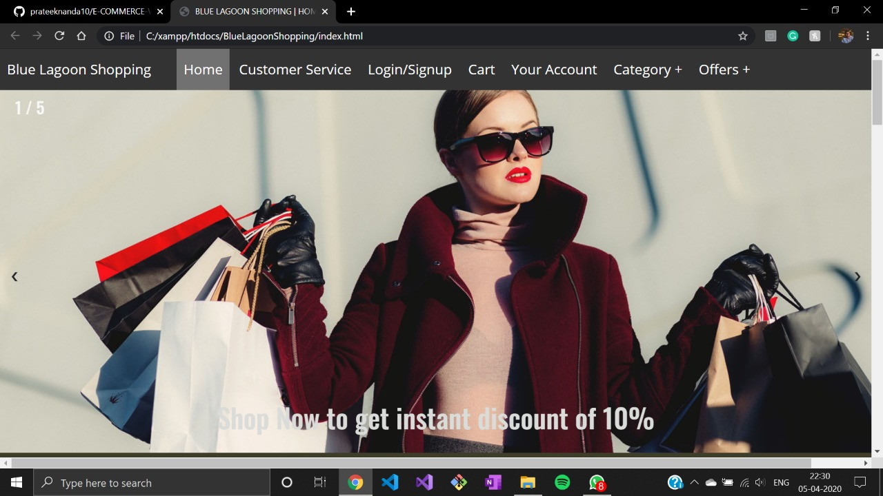2.**HOME PAGE**

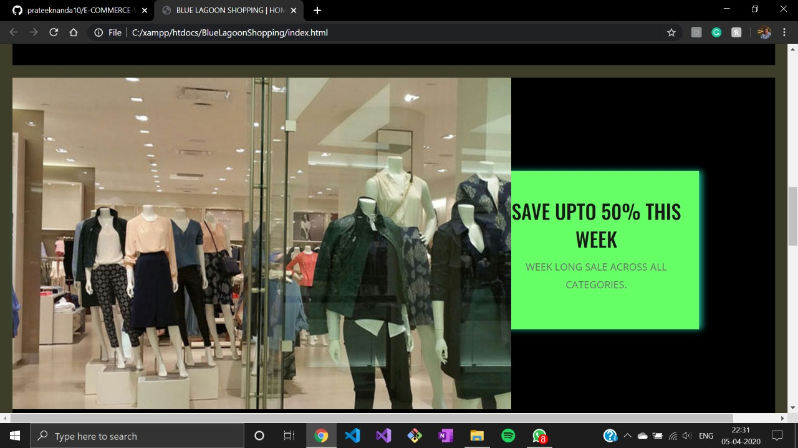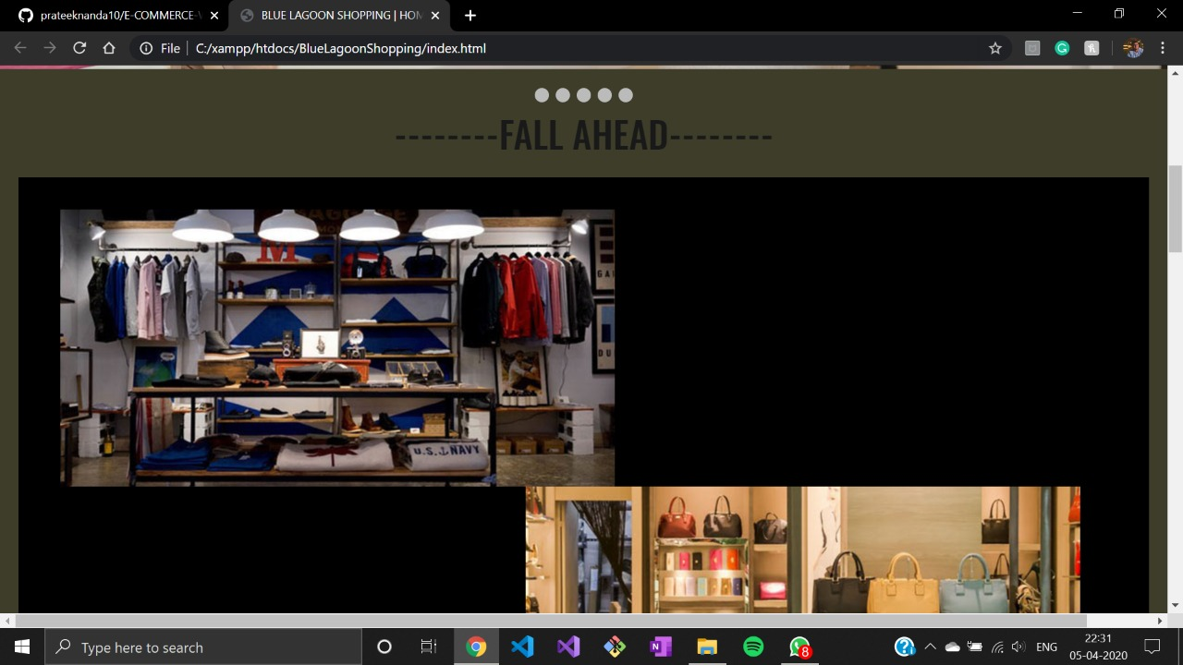

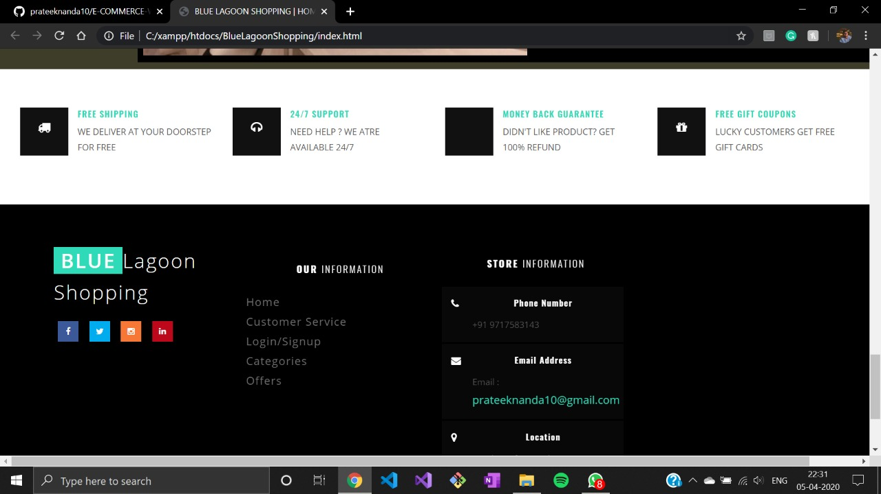

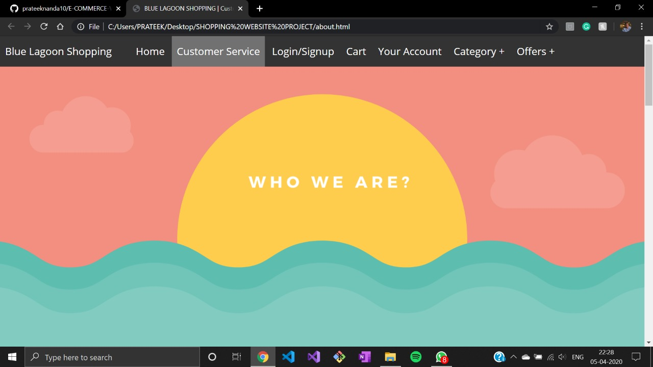3.**CUSTOMER SERVICES**

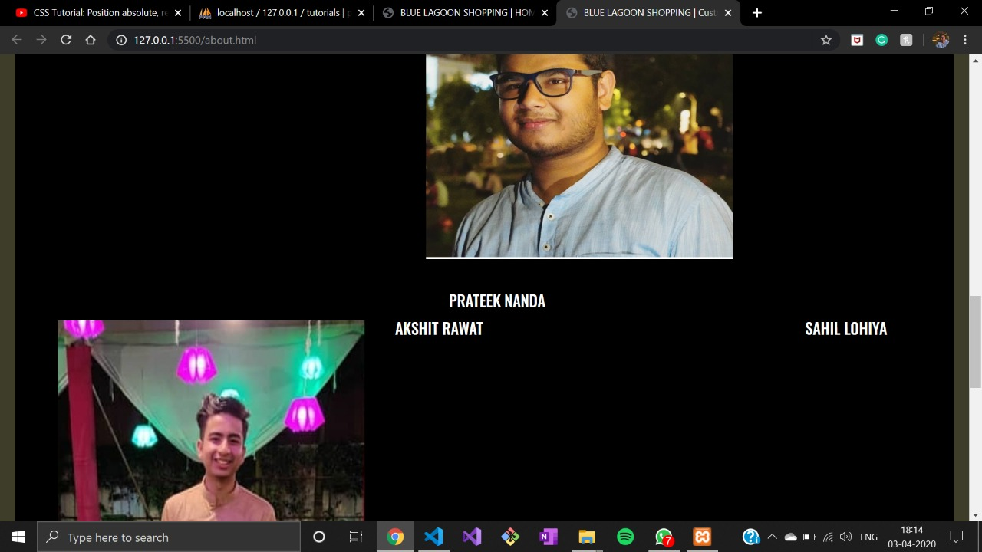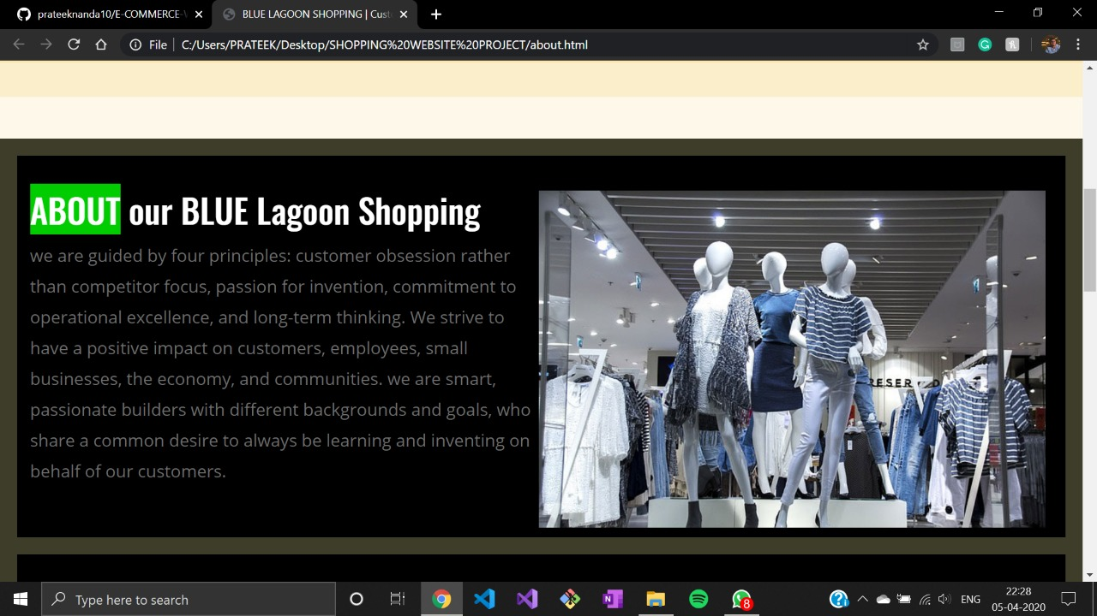

4.**LOGIN/SIGNUP**

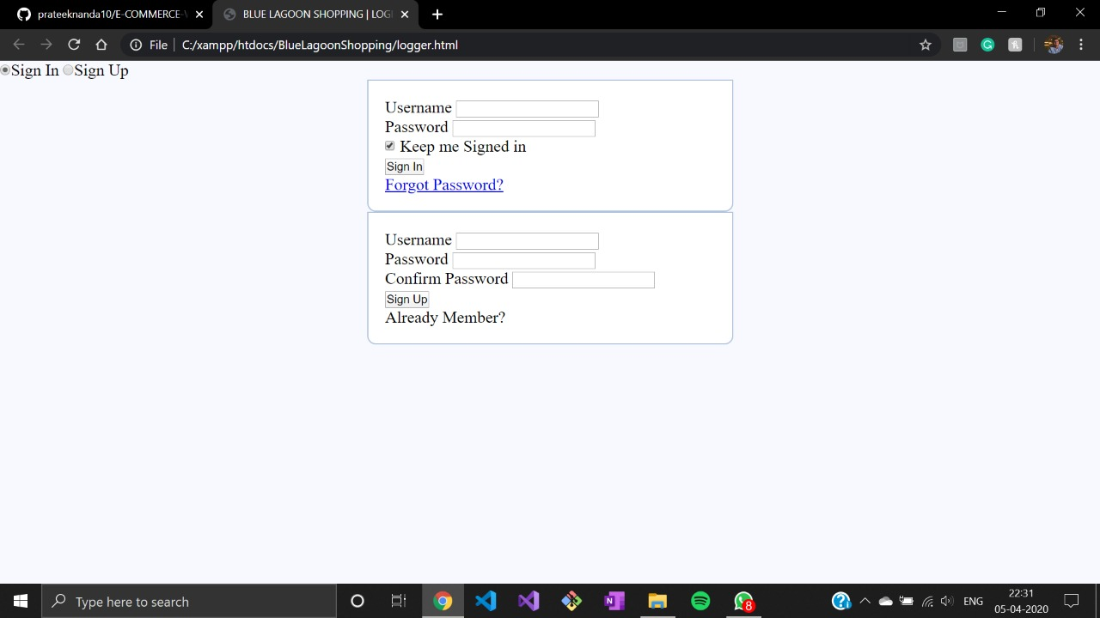

5.**CATEGORY**

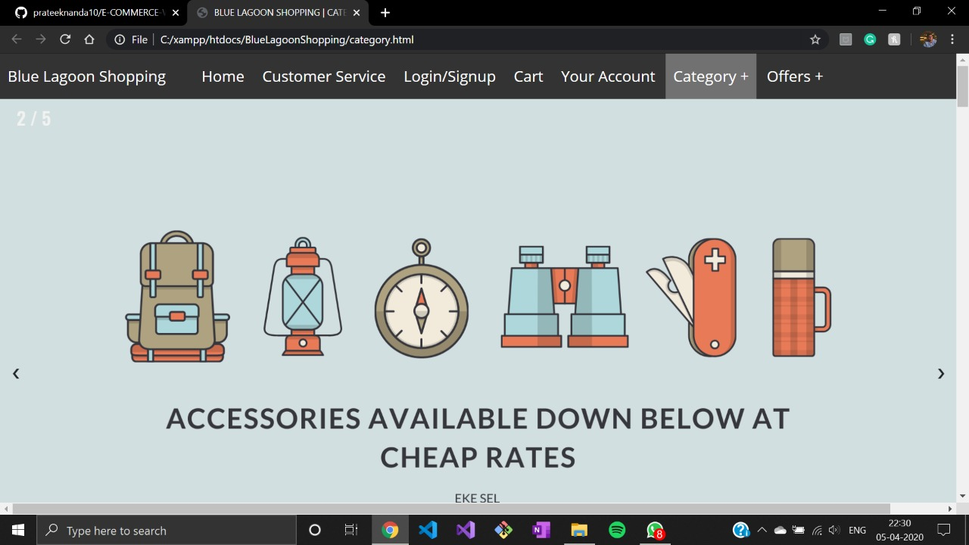

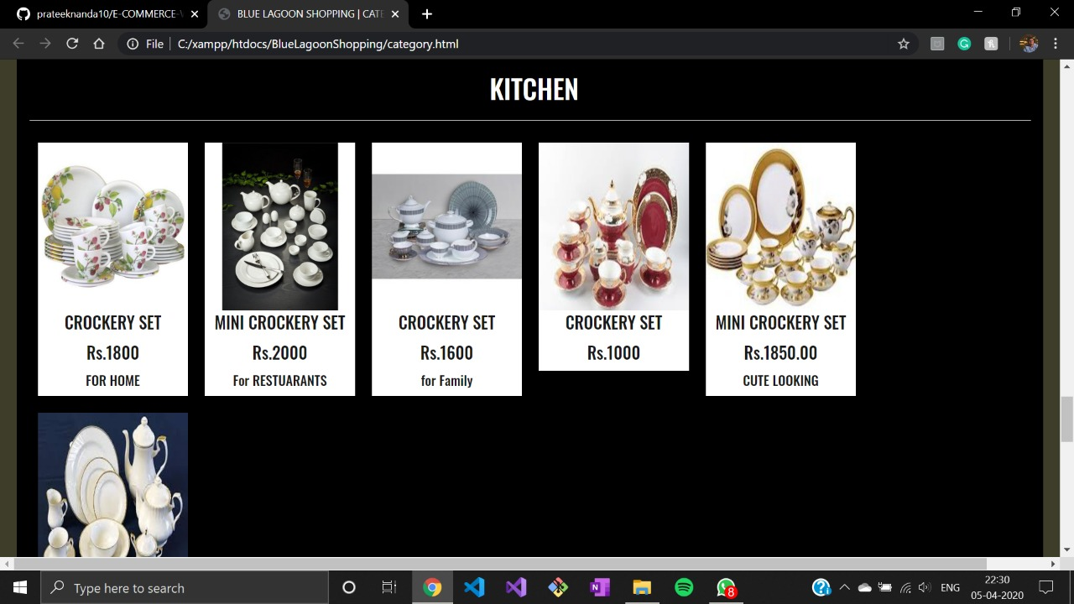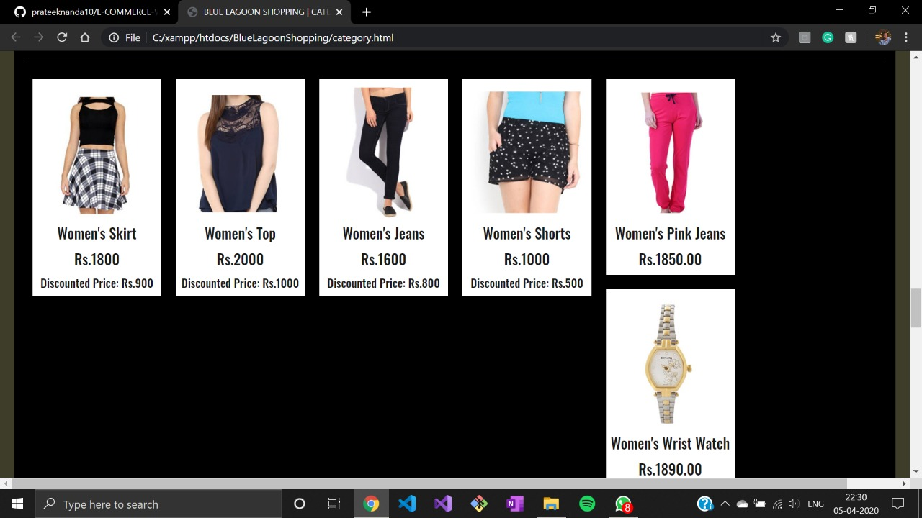

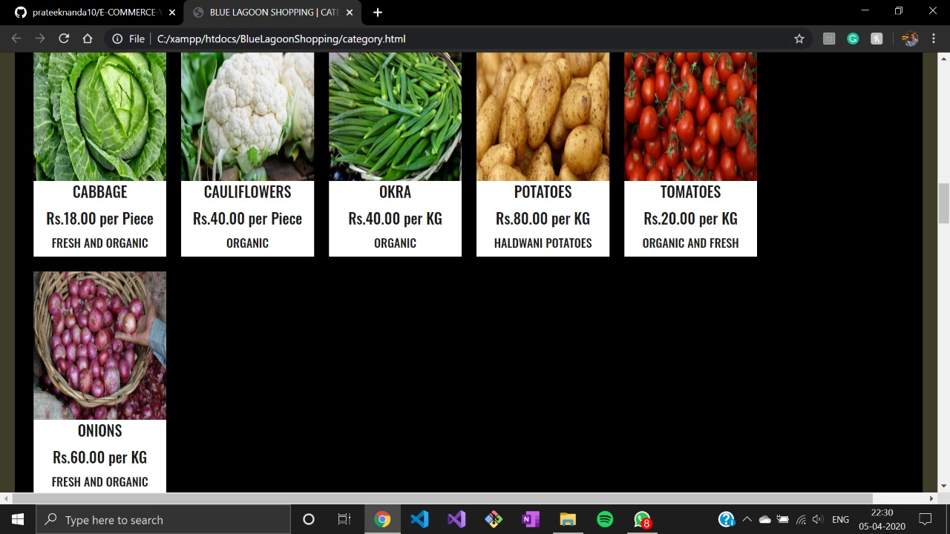

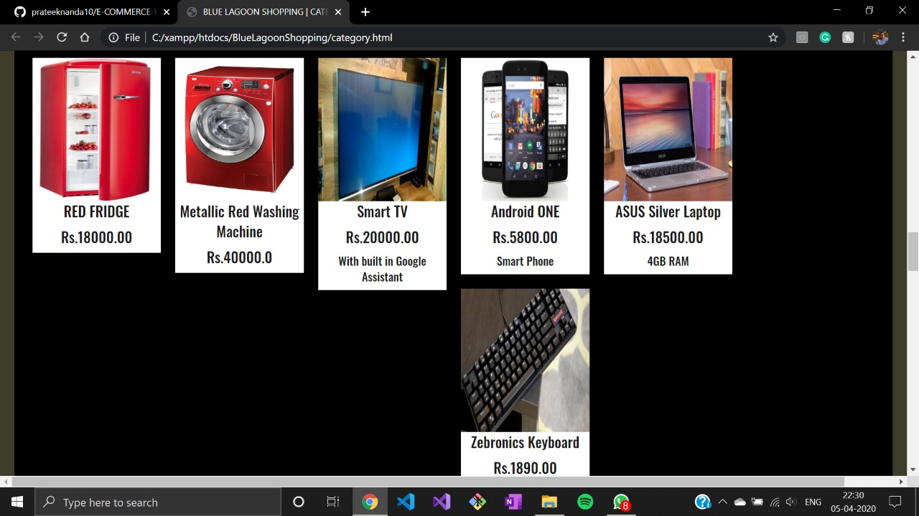

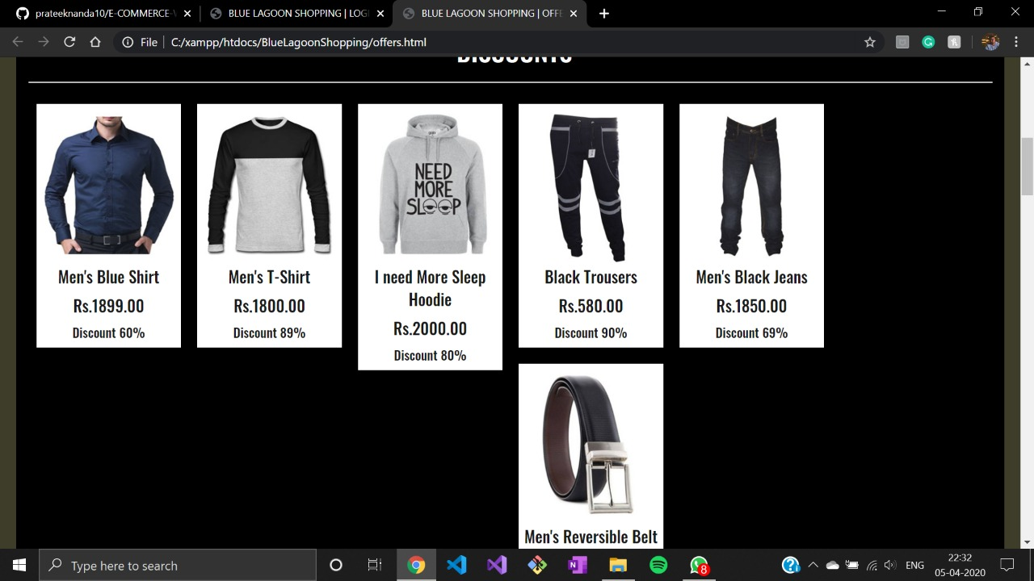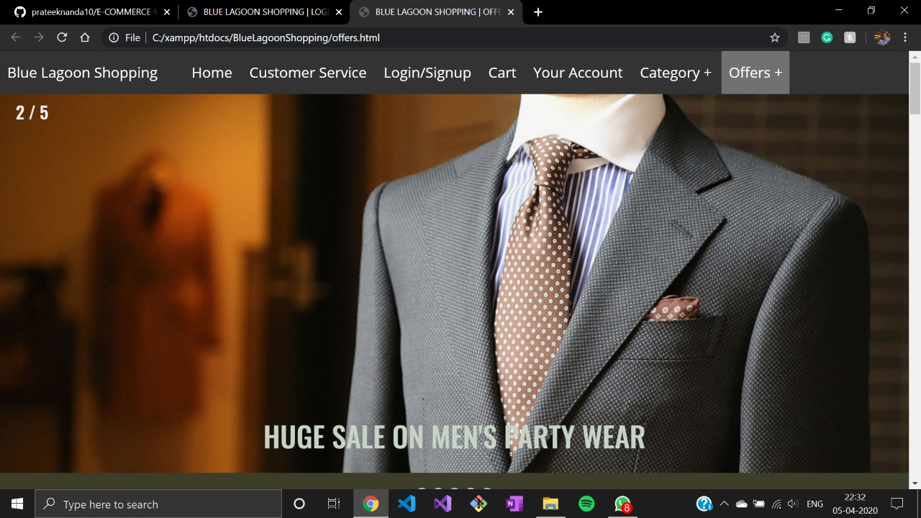6.**OFFERS**

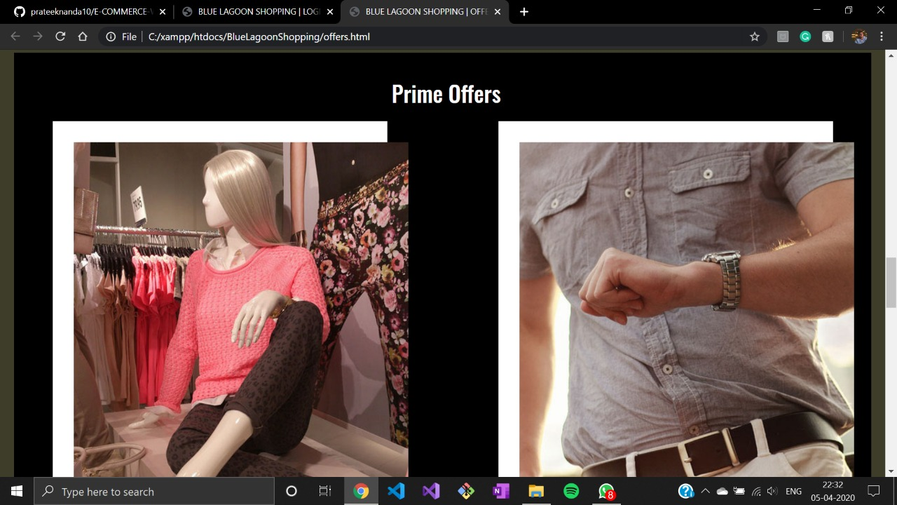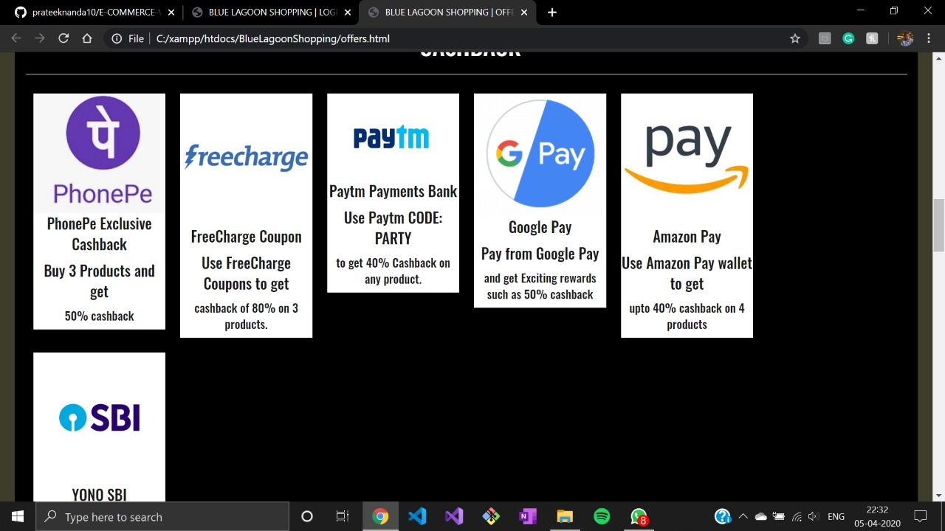

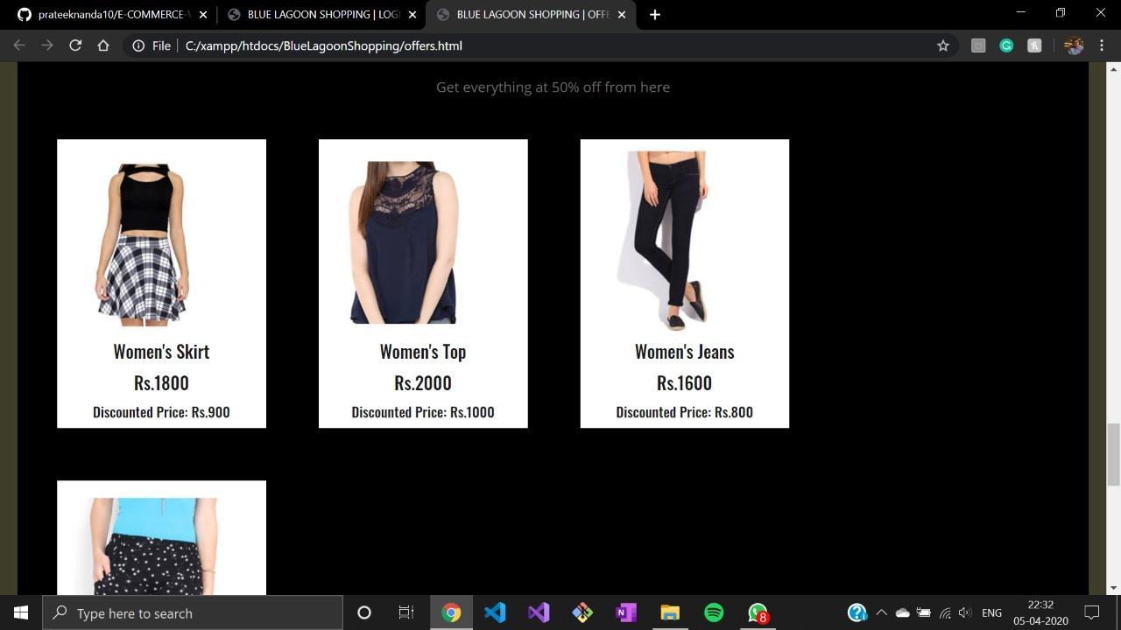

**CREATED BY:**

* **Prateek Nanda:** *Homepage, Offers, Logger module, Design theme.*
* **Akshit Rawat*:*** *Customer services, Category section, Login page.*
* **Sahil Lohiya:** *Login design, Category templates.*